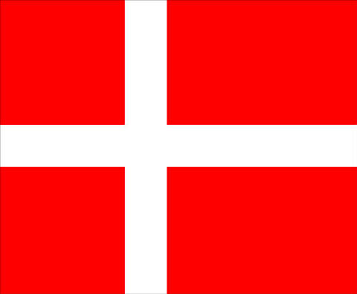
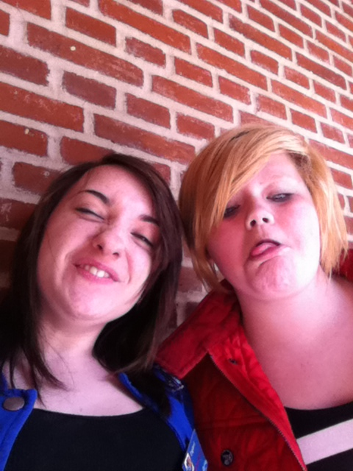
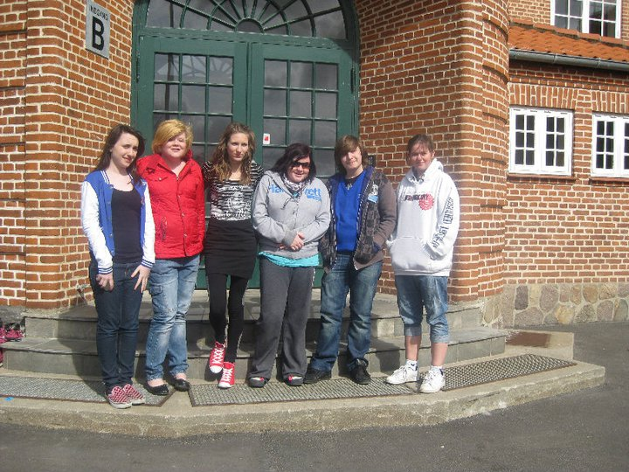
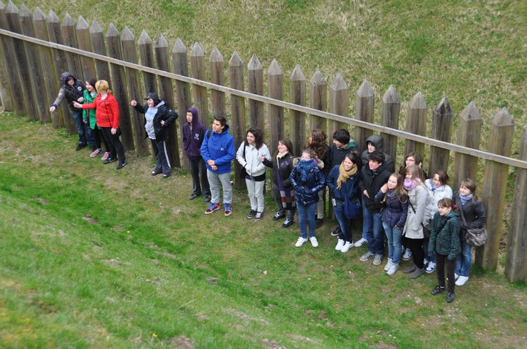
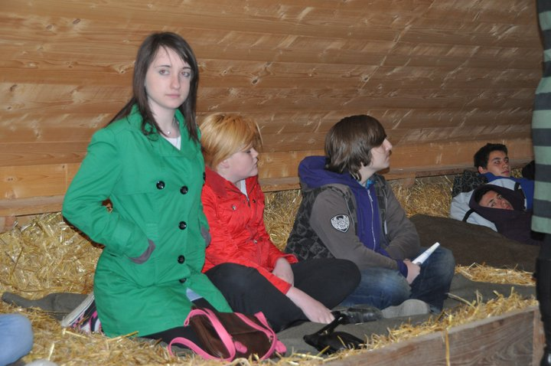

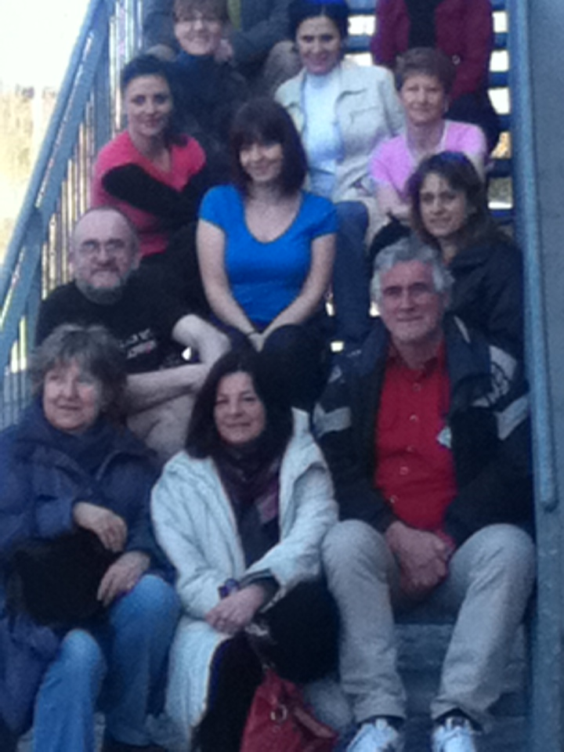
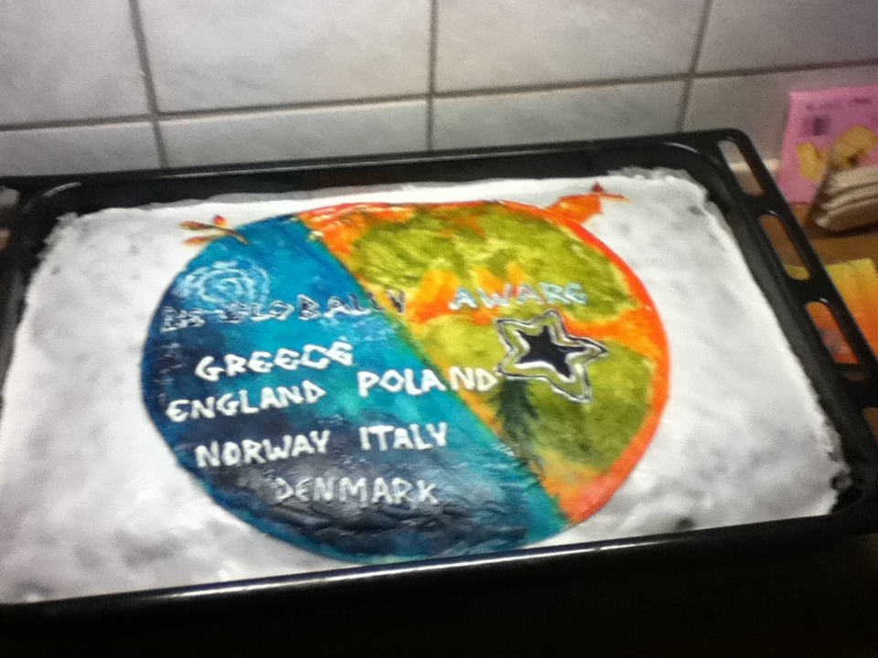
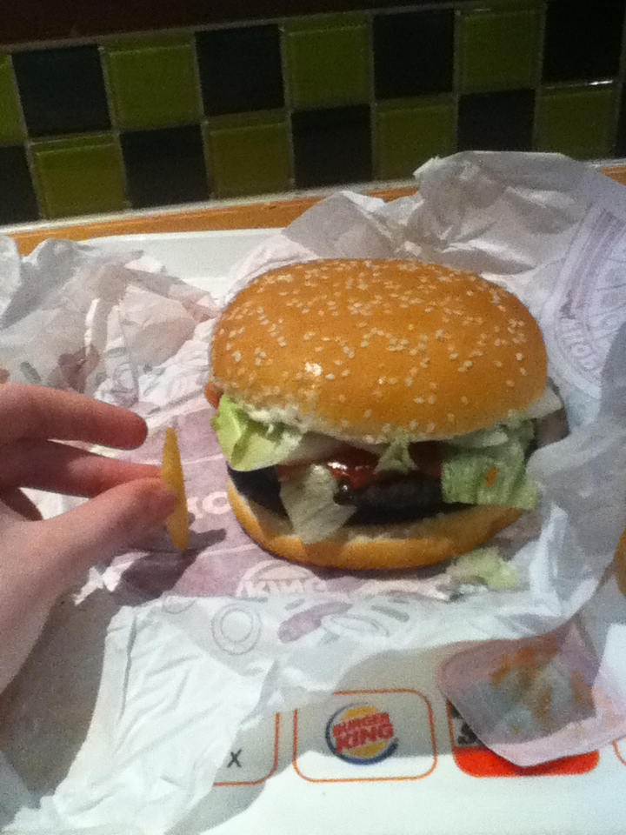
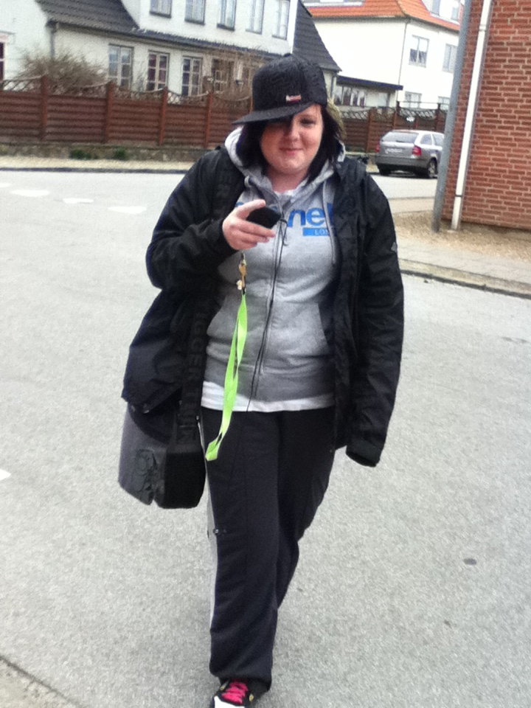
In Denmark we learnt a wide variety of life skills from saving water and energy to how to live in a Danish house. It was a very good experience and I am sure to stay in touch with Jane , Torben, Kiki and Thomas which is the family I stayed with for the 5 days I was in Denmark.

COMENIUS...
DENMARK VISIT...
Our Comenius trip to Denmark...
Our trip to Denmark gave us a lot of experience, I learnt so much about how to live with a Danish family, living with them taught me a lot about the way I approach other people, and how the students at the school were really trusted as the whole school was open. The fact that the teachers trusted the students they taught was a really good thing,we did a lot..we had a sports day, we also did bread making, we went out for a meal and learnt some Danish.One word I learnt was moy-n which meant more or less everything.We communicated well but sometimes the Danish students would get confused and talk Danish although we were English. Overall I think Denmark was a very good visit and it has taught me a lot,even though we had to do a lot of work it all payed off in the end! And I think the next group will really enjoy Italy.

Denmark Visit!

